LAB 10 ANSWERS

- Write a C program to demonstrate the single and double pointers.

PROGRAM:
#include <stdio.h>
int main()
{
int value = 10;
int *singlePtr = &value;
int **doublePtr = &singlePtr;
printf("Original value: %d\n", value);
printf("Address of value: %p\n\n", (void *)&value);
printf("Value via singlePtr (*singlePtr): %d\n", *singlePtr);
printf("Address pointed to by singlePtr (singlePtr): %p\n", (void *)singlePtr);
printf("Address of singlePtr (&singlePtr): %p\n\n", (void *)&singlePtr);
printf("Value via doublePtr (**doublePtr): %d\n", **doublePtr);
printf("Address pointed to by doublePtr (*doublePtr): %p\n", (void *)*doublePtr);
printf("Address of doublePtr (&doublePtr): %p\n\n", (void *)&doublePtr);
**doublePtr = 25;
printf("Value after modification using doublePtr: %d\n", value);
return 0;
}
OUTPUT:
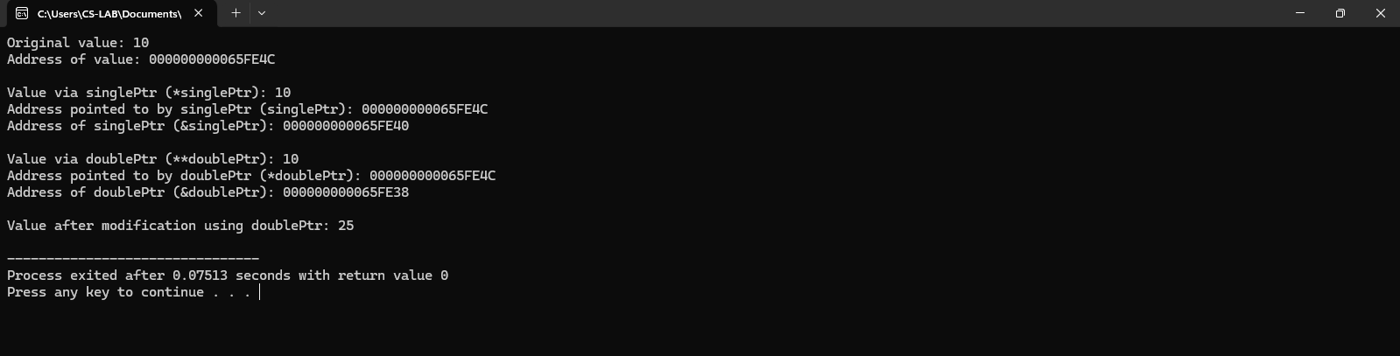

2. Sum of n numbers in an array using pointers.
PROGRAM:
#include <stdio.h>
int main() {
int arr[5] = {1, 2, 3, 4, 5};
int *ptr = arr;
int sum = 0;
for (int i = 0; i < 5; i++) {
sum += *(ptr + i); // Add elements using pointer arithmetic
}
printf("Sum of array elements: %d\n", sum);
return 0;
}
OUTPUT:
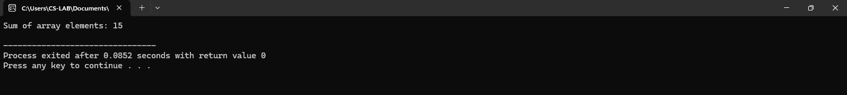

3. Finding the largest element in an array using pointers and double pointers.
PROGRAM USING SINGLE POINTER:
#include <stdio.h>
int main()
{
int arr[100], n;
int *ptr, large;
printf("Enter number of elements: ");
scanf("%d", &n);
printf("Enter %d elements:\n", n);
for (int i = 0; i < n; i++) {
scanf("%d", &arr[i]);
}
ptr = arr;
large = *ptr;
for (int i = 1; i < n; i++)
{
if (*(ptr + i) > large)
{
large = *(ptr + i);
}
}
printf("The largest element in the array is: %d \n",large);
return 0;
}
OUTPUT:
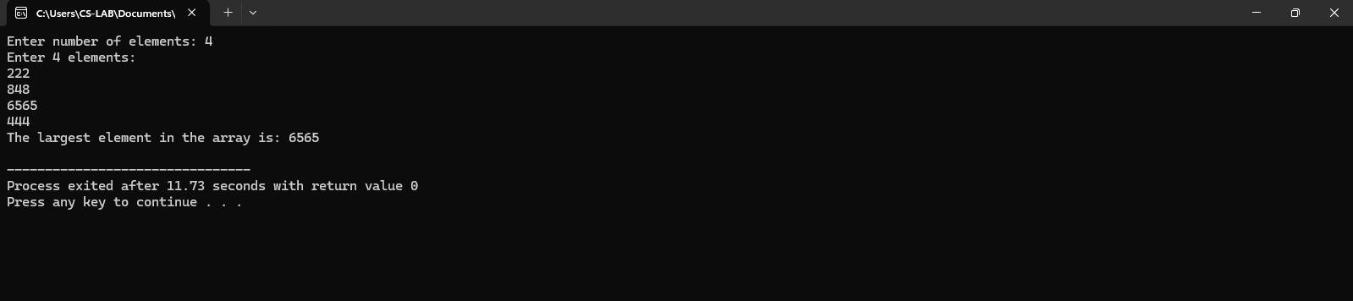
PROGRAM USING DOUBLE POINTER:
#include <stdio.h>
int main()
{
int arr[100], n, i;
int *p;
int **dp;
int max;
printf("Enter number of elements: ");
scanf("%d", &n);
printf("Enter array elements:\n");
for (i = 0; i < n; i++)
scanf("%d", &arr[i]);
p = arr;
dp = &p;
max = **dp;
for (i = 1; i < n; i++)
{
*p = arr[i];
if (**dp < arr[i])
max = arr[i];
}
printf("Largest element = %d\n", max);
return 0;
}
OUTPUT:
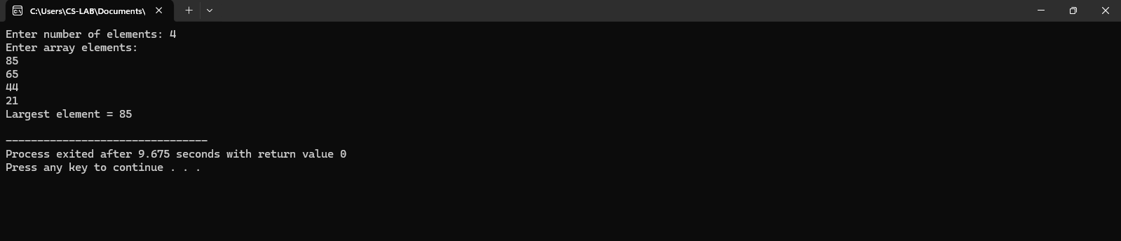
4. C Program to swap values using pointers and Double Pointers.
PROGRAM:
#include <stdio.h>
int main() {
int a, b, temp;
int *p1, *p2;
printf("Enter two numbers: ");
scanf("%d %d", &a, &b);
p1 = &a;
p2 = &b;
temp = *p1;
*p1 = *p2;
*p2 = temp;
printf("After swapping:\n");
printf("a = %d\n", a);
printf("b = %d\n", b);
return 0;
}
OUTPUT:
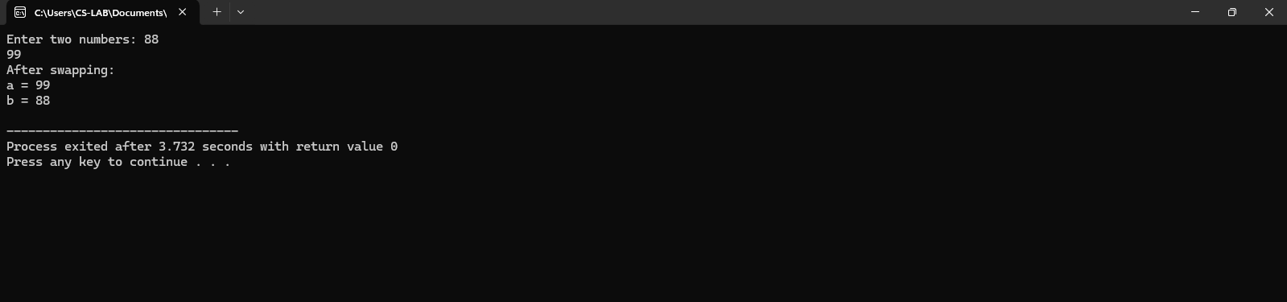
PROGRAM USING DOUBLE POINTER:
#include <stdio.h>
int main() {
int a, b, temp;
int *p1, *p2;
int **dp1, **dp2;
printf("Enter two numbers: ");
scanf("%d %d", &a, &b);
p1 = &a;
p2 = &b;
dp1 = &p1;
dp2 = &p2;
temp = **dp1;
**dp1 = **dp2;
**dp2 = temp;
printf("After swapping:\n");
printf("a = %d\n", a);
printf("b = %d\n", b);
return 0;
}
OUTPUT:
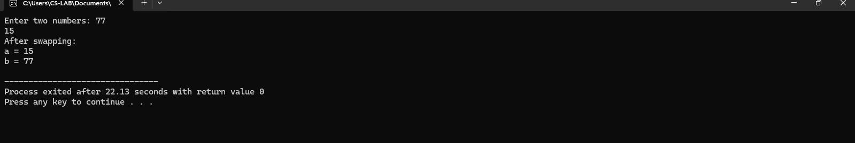
5. Write a C program to perform dynamic memory allocation.
PROGRAM:
#include <stdio.h>
#include <stdlib.h>
int main() {
int *numbers;
int count;
printf("Enter the number of elements you want to store: ");
scanf("%d", &count);
numbers = (int *)malloc(count * sizeof(int));
if (numbers == NULL) {
printf("Memory allocation failed! Exiting program.\n");
return 1;
}
printf("Enter %d integer elements:\n", count);
for (int i = 0; i < count; i++)
{
printf("Element %d: ", i + 1);
scanf("%d", &numbers[i]);
}
printf("\nThe entered elements are: ");
for (int i = 0; i < count; i++) {
printf("%d ", numbers[i]);
}
printf("\n");
free(numbers);
numbers = NULL;
return 0;
}
OUTPUT:
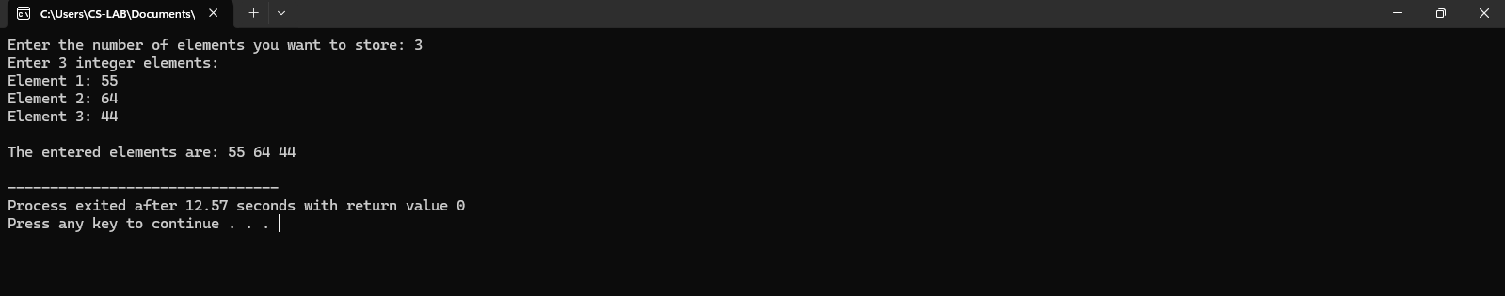
6. Write a C program to dynamically allocate memory for storing the marks of N students. The program should read the marks from the user, display them, and calculate the average mark of the class.
PROGRAM:
#include <stdio.h>
#include <stdlib.h>
int main()
{
int N;
float *marks;
float sum = 0.0, average;
printf("Enter the number of students: ");
scanf("%d", &N);
if (marks == NULL)
{
printf("Memory allocation failed!\n");
return 1;
}
for (int i = 0; i < N; i++) {
printf("Enter marks for student");
scanf("%f", (marks + i));
sum += *(marks + i);
}
printf("\nMarks of all students:\n");
for (int i = 0; i < N; i++) {
printf("Student %.2f\n", marks + i);
}
average = sum / N;
printf("\nAverage marks = %.2f\n", average);
free(marks);
return 0;
}
Output:
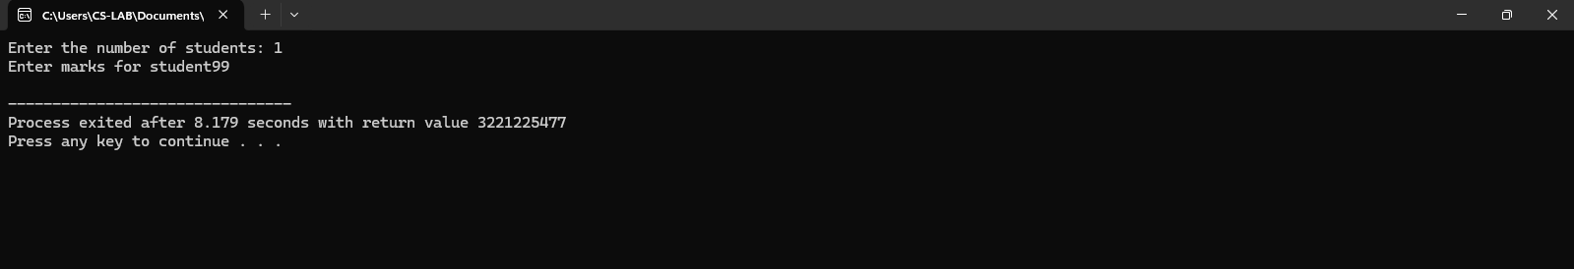
7. A company initially stores salaries of 4 employees. Later, 3 more employees join, and the program needs to adjust memory dynamically to store their salaries without losing the existing data. Task:
● Allocate memory for 4 employees’ salaries.
● Input and display those salaries.
● Expand memory dynamically to accommodate 3 more employees.
● Input and display salaries of all 7 employees.
Program:
#include <stdio.h>
#include <stdlib.h>
int main() {
int i;
float *salaries;
salaries = (float *)malloc(4 * sizeof(float));
if (salaries == NULL) {
printf("Memory allocation failed!\n");
return 1;
}
printf("Enter salaries of 4 employees:\n");
for (i = 0; i < 4; i++)
{
printf("Employee %d: ", i + 1);
scanf("%f", (salaries + i));
}
printf("\nSalaries of 4 employees:\n");
for (i = 0; i < 4; i++)
{
printf("Employee %d: %.2f\n", i + 1,*(salaries + i));
}
salaries = (float *)realloc(salaries, 7 * sizeof(float));
if (salaries == NULL) {
printf("Memory reallocation failed!\n");
return 1;
}
printf("\nEnter salaries of 3 new employees:\n");
for (i = 4; i < 7; i++) {
printf("Employee %d: ", i + 1);
scanf("%f", (salaries + i));
}
printf("\nSalaries of all 7 employees:\n");
for (i = 0; i < 7; i++) {
printf("Employee %d: %.2f\n", i + 1,*(salaries + i));
}
free(salaries);
return 0;
}
Output:
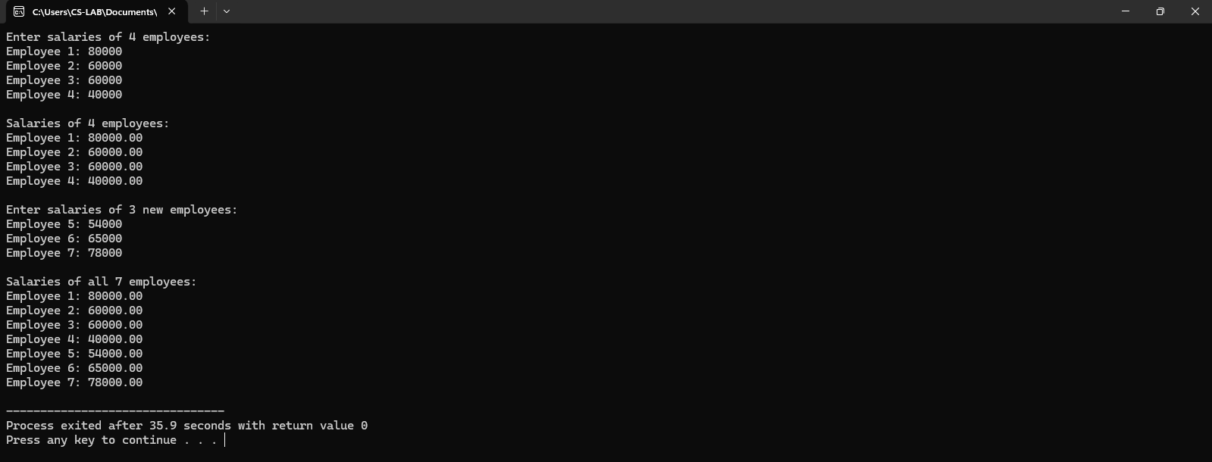
8. A sports coach wants to record the scores of players in a tournament. Task:
● Ask the user to enter the number of players N.
● Dynamically allocate memory to store the scores of N players.
● Input the scores for all players.
● Display the scores of each player.
● Calculate and display the highest, lowest, and average score.
● Free the allocated memory after use.
Program:
#include <stdio.h>
#include <stdlib.h>
int main()
{
int N, i;
int *scores;
int high, low;
float sum = 0.0, avg;
printf("Enter number of players: ");
scanf("%d", &N);
scores = (int *)malloc(N * sizeof(int));
if (scores == NULL) {
printf("Memory allocation failed!\n");
return 1;
}
for (i = 0; i < N; i++) {printf("Enter score for player %d: ", i + 1);
scanf("%d", (scores + i));
sum += *(scores + i);
}
high= low = *(scores + 0);
for (i = 1; i < N; i++)
{
if (*(scores + i) > high)
high = *(scores + i);
if (*(scores + i) < low)
low = *(scores + i);
}
avg = sum / N;
printf("\nScores of players:\n");
for (i = 0; i < N; i++) {
printf("Player %d: %d\n", i + 1,*(scores + i));
}
printf("\nHighest score: %d\n", high);
printf("Lowest score: %d\n", low);
printf("Average score: %.2f\n", avg);
free(scores);
return 0;
}
Output:
